Why Earth is not hitting the sun?

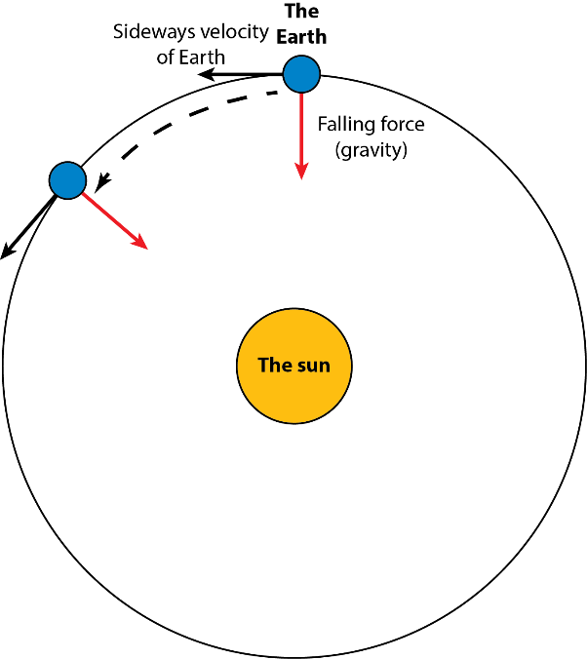
Dear Ramesh,
I understand why you might think that the Earth is hitting the sun. The Sun is really big and because of its large mass, it pulls the Earth toward itself.
In the diagram to the right, I pictured the sun in yellow, the Earth in blue and the Earth’s path around the sun (the orbit) with a black circle. The orbit is actually and ellipse and not a circle, but that doesn’t matter here. The red arrow is the pull of the sun on the Earth. At the same time, the Earth is also moving in a direction marked by the black arrow. If the Earth was not moving, only the red arrow would be there, and the Earth would crush into the sun. At the same time, if the sun would disappear, and the red arrow would disappear, the Earth would just shoot off in a straight line in the direction of the black arrow. So, why does the Earth not crash into the sun? And why does the Earth not shoot off in a straight line? Basically, the red arrow and the black arrow are in a balance. As a result, the Earth rotates around the sun along the black circle.

