Meiosis

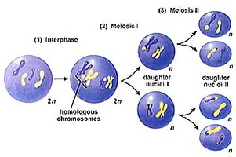
¹ Living things reproduce to make more organisms like themselves. When organisms reproduce, many traits of the parents are passed to the new organism. Reproduction is necessary for the survival of the species. If organisms didn't reproduce, the species would die out.
² Many organisms reproduce by combining cells from two different parents. This type of reproduction is called sexual reproduction. In sexual reproduction, the offspring receive genetic material from both parents of different sexes. Plants, insects, animals, some fungi, and people all make more of themselves by sexual reproduction.
³ Special cells, sperm and egg cells, are used in sexual reproduction. These cells, called gametes, form by a type of cell division called meiosis. Cells formed through meiosis have only half the number of chromosomes or genetic material of the parent cell. For example, most cells of fruit flies have eight chromosomes, arranged as four similar pairs. But the egg or sperm cells of a fruit fly have only four chromosomes. Humans have forty-six chromosomes, arranged in twenty-three pairs. But human egg and sperm cells only have twenty-three chromosomes. How does this happen?
⁴ There are two ways cells replicate: mitosis and meiosis. Mitosis is the simple duplication of a cell and all of its parts. It duplicates its DNA and divides, and the two new daughter cells are exactly the same. They have the same genetic code. One cell becomes two cells that are identical. All cells in the human body divide in this way-- all except the egg and sperm cells.
⁵ These cells are different. One egg and one sperm cell will join together in a process called fertilization. If each of them carried a full set of chromosomes, fertilization would result in a new organism having twice as many chromosomes as it should have. So for these special cells, there must be two cell divisions. This is called meiosis (pronounced my-OH-sis).
⁶ Remember the cell cycle steps of mitosis? They are interphase, prophase, metaphase, anaphase, and telophase. In meiosis, the cell goes through these steps twice. Scientists call each group meiosis I and meiosis II, but it is basically just two cell divisions. The interphase that happens between the two is very short, and the DNA is not duplicated a second time. Another difference in meiosis and mitosis is that four daughter cells are created from the original cell. Each of the four cells has half the DNA of the parent cell. This is known as a haploid cell. Haploid just means that it has half the regular number of chromosomes. A normal cell with the correct number of chromosomes is called diploid.
⁷ The process of meiosis allows each new offspring to have different genes from the parents. This process called crossing over mixes up the genes so that the new cells are not duplicates of the parent cell. In fact, with humans having 23 pairs of chromosomes, there are over 8 million combinations possible! This is why children are not exactly like their parents. It also explains why brothers and sisters are never exactly alike.
⁸ The only exception to this is in the case of identical twins. Identical twins form from one egg cell that has been fertilized by one sperm cell. Because they form from the same 46 chromosomes, 23 from each parent, they do have the same genes. Not all twins are identical. Sometimes twins result from the female releasing two egg cells at the same time. Each egg cell has different genes, and each egg cell is fertilized by two different sperm cells, also having different genes. These twins are called fraternal. They may look no more alike than any other set of siblings. Fraternal twins can be the same sex, or they can be the opposite sex. Identical twins, however, are always the same sex.
⁹ Scientists can now clone plants and some animals. Cloning can produce offspring that are genetically identical to the parent offspring. Only one parent is needed. Cloning uses cells or tissues from the body of the parent organism to produce a new organism with identical traits.

Review: Comparison of Mitosis and Meiosis
¹ You have now learned about two versions of cell reproduction in eukaryotic organisms. Figure 9-20 (picture below) compares these processes. Mitosis, which provides for growth, repair, and asexual reproduction, produces daughter cells that are genetically identical to the parent cell. Meiosis, which takes place in a subset of specialized cells in sexually reproducing organisms, yields haploid daughter cells with only one set of homologous chromosomes. This set consists of one member of each homologous pair.
² In both mitosis and meiosis, the chromosomes duplicate only once, in the preceding interphase. Mitosis involves one division of the genetic material in the nucleus, and it is usually accompanied by cytokinesis, producing two diploid cells. Meiosis involves two nuclear divisions, yielding four haploid cells.
³ The key events that distinguish meiosis from mitosis occur during the stages of meiosis I. In prophase I, the duplicated homologous chromosomes form tetrads, and crossing over occurs. Then, during metaphase I, the tetrads (rather than individual doubled chromosomes) are aligned at the center of the cell. In anaphase I, sister chromatids stay together and go to the same pole when the homologous chromosomes separate. At the end of meiosis I, the chromosome number in each of the two daughter cells is haploid, but each chromosome still consists of two sister chromatids. Meiosis II is basically identical to mitosis. The sister chromatids separate, and each cell divides in two. Because these cells are already haploid, the cells they produce are haploid, too.
⁴ Mitosis and meiosis both make it possible for cells to inherit genetic information in the form of chromosome copies. In the next chapter, you will have the opportunity to connect this property of chromosomes to the inheritance of genes for specific traits, such as your blood type. Keep in mind the process of meiosis and the production of gametes as you study the patterns of inheritance. You'll find that an understanding of how meiosis distributes chromosomes will make it easier for you to follow how specific traits are inherited.
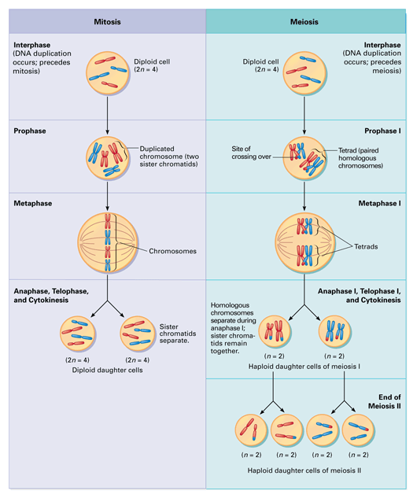
Figure 9-20
Both mitosis and meiosis begins after the chromosomes have been duplicated during interphase. Though similar, the results of the two processes differ in the number of cells produced and in the number of chromosomes the cells contain.

